The Poinsettia’s On our poinsettia tree
have been given to the Glory of God by:

Mike & Brenda Sing in honor of our mothers, Joyce Sing and Darlene Johnson.
Janet Pasche in memory of Willis Pasche and the Kobler Family.
The Heinz/Majerus Family in memory of Gregory “John” Majerus Jr, Charles “Chuck” Heinz, and Nina Pilla.
Gib & Sharon Decker in memory of our parents: Gilbert & Margaret, Ray & Florence, and brothers Doug, Neal, and Ronald.
Helen Schumacher in memory of Glen Schumacher and parents: Alice & Lloyd Schumacher and Lee & Irene Rogers.
Mark & Mary Olson in memory of Clinton & Helen Olson, Jean Ann Schumacher, and Glen Schumacher.
Carolyn & Dennis Verthein in memory of Doris & Clayton Taylor, Augusta & Kermit Verthein, and Aunt Alice Hendrickson.
Mike & Cheryl Lovlien in memory of parents & grandparents.
Roger & Jodi Schumacher Family in memory of Ray & Florence Schumacher and Bob & Gloria Bain.

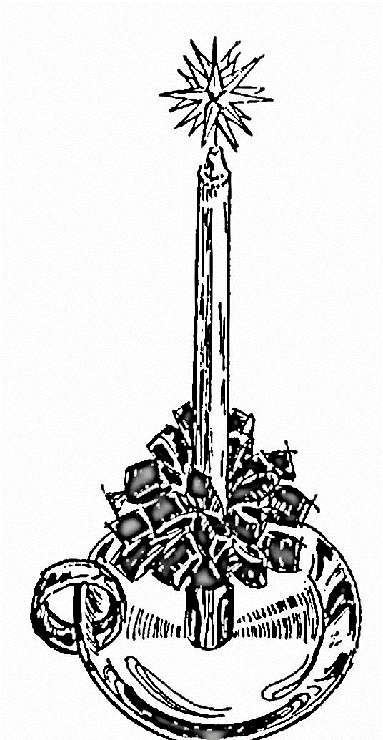

Our Savior’s Moravian Church

Christmas Eve
Candlelight Service

December 24, 2021

OUR SAVIOR’S MORAVIAN CHURCH
ALTURA, MINNESOTA
website: oursaviorsmoravian.org

December 24, 2021
Christmas Eve Candlelight Service

The Purpose of this Church shall be to glorify God in adoration, Love and service as God’s missionary to our community, our nation, and our world, bearing witness to God’s redeeming grace in Jesus Christ.”

Watchword for Christmas: And the word became flesh and lived among us, and we have seen his glory, the glory as of a father’s only son, full of grace and truth. John 1:14
Prelude O Come All Ye Faithful (Brass Ensemble)
Welcome
Lighting of the Christ Candle
Tonight, we conclude our Advent journey as we light the Christ Candle, welcoming the one promised in scripture.
He is called Emmanuel: God with us!
We celebrate the hope brought to earth by our Wonderful Counselor
He is called Emmanuel: God with us!
We rejoice in the strength of power of a Mighty God
He is called Emmanuel: God with us!
We sing of peace on earth and good will to all people
He is called Emmanuel: God with us!
And we lift our hearts in praise to our Everlasting Creator.
He is called Emmanuel: God with us! Joy to the world, the Lord has come!
*Greeting Each Other in Christ
*Hymn Joy to the World #294
Scripture Isaiah 9: 2-7
Hymn Angels We Have Heard on High #288
Scripture John 1: 1-14
Prayer
Scripture Luke 2: 1-20
Message At the Manger
The Candlelight Service Insert
*Benediction
*Thank you for sharing the celebration of the birth of Christ tonight!*
**********************************************************
In Our Worship This Evening
Pastor Rev. Barry Lehman
Brass Director Steve Pasche
On the Calendar
December 26: Worship–9:30am Christmas Hymn Sing Sunday
**No Sunday School
January 2: Worship – 9:30am – Drawing of Watchwords
**No Sunday School

A Christmas Eve Gift
In past years, our congregation has traditionally given a gift to those who attend the Christmas Eve Candlelight Service. We give thanks for the meaningfulness and the joy that these gifts have brought in years past.
This year, the Joint Board has decided to continue our new tradition of offering a gift to the needs of our world this Christmas Eve. Instead of members receiving a gift from the church, the congregation will be giving to the mission of Hometown Resource Center in St. Charles to help them continue to care for and feed those whom they serve in our community.
For each person in attendance tonight a $1.00 donation will be made on behalf of the congregation. In addition, a freewill offering will be collected in the offering boxes at the back of the sanctuary during our Christmas Eve service for members and friends who would like to give a donation to this Christ driven ministry. Merry Christmas and may the love of Christ fill your heart.

Candlelight Service

The light of the world is coming.
Jesus Christ in born this night!
This is how God has decided to come into the world, as a baby. Born not in a city of power or of riches.
Born in a city of simplicity; lowly Bethlehem.
Born to be with us, to walk with all who are weary,
And to reveal the love and grace of God.
A new beginning has dawned!
A beginning of peace and love.

**Distribution of candles**

O Come, All Ye Faithful (Hymn 283)
O come, all ye faithful, joyful and triumphant, O come ye, O come ye to Bethlehem; come and behold him, born the king of angels;
O come, let us adore him, O come, let us adore him, O come, let us adore him, Christ, the Lord
The highest, most holy, light of light eternal, born of a virgin, a mortal he comes; Son of the Father now in flesh appearing!
O come, let us adore him, O come, let us adore him, O come, let us adore him, Christ, the Lord
O sing, choirs of angels, sing in exultation, sing, all ye citizens of heav’n above: glory to God, glory in the highest;
O come, let us adore him, O come, let us adore him, O come, let us adore him, Christ, the Lord
Yea, Lord, we greet thee, born this happy morning; Jesus, to thee be all glory giv’n; Word of the Father, now in flesh appearing!
O come, let us adore him, O come, let us adore him, O come, let us adore him, Christ, the Lord

**Spreading of the Light**
O Little Town of Bethlehem (Hymn 282)
O little town of Bethlehem, how still we see thee lie;
Above thy deep and dreamless sleep the silent stars go by.
Yet in thy dark streets shineth the everlasting Light;
the hopes and fears of all the years are met in thee tonight.
For Christ is born of Mary, and gathered all above,
while mortals sleep, the angels keep their watch of wondering love.
O morning stars, together proclaim the holy birth;
and praises sing to God the King, and peace to all on earth
How silently, how silently, the wondrous gift is given!
So God imparts to human hearts the blessings of the heaven.
No ear may hear His coming, but in this world of sin,
where meek souls will receive Him still, the dear Christ enters in.
O holy Child of Bethlehem, descend to us, we pray;
cast out our sin, and enter in, be born to us today.
We hear the Christmas angels, the great glad tidings tell;
O come to us, abide with us, our Lord Emmanuel

Morning Star, O Cheering Sight (Hymn 281)
**The Youth Choir will lead us in singing with the Congregation singing the BOLD words.**

Morning Star, O cheering sight!
Ere thou cam’st, how dark earth’s night!
Morning Star, O Cheering Sight!
Ere thou cam’st, how dark earth’s night!
Jesus mine, IN ME SHINE. In me shine, JESUS MINE.
FILL MY HEART WITH LIGHT DIVINE.

Morning Star, thy glory bright far excels the sun’s clear light;
Morning Star, Thy glory bright
far excels the sun’s clear light;
Jesus be, constantly. constantly, Jesus be.
More than thousand suns to me.
Thy glad beams, thou Morning Star, cheer the nations near and far.
Thy glad beams, thou morning star,
cheer the nations near and far.
Thee we own, Lord Alone. Lord alone, Thee we own.
Our dear savior, god’s dear son.

Morning Star, my soul’s true light, tarry not dispel my night.
Morning Star, my soul’s true light,
tarry not dispel my night.
Jesus mine, IN ME SHINE. In me shine, JESUS MINE.
FILL MY HEART WITH LIGHT DIVINE.

Silent Night, Holy Night (Hymn 297)
“Silent night, holy night! All is calm, all is bright
round yon virgin, mother and child.
Holy infant, so tender and mild,
sleep in heavenly peace, sleep in heavenly peace.

Silent night, holy night! Shepherds quake at the sight;
glories stream from heaven afar, Heav’nly hosts sing, Alleluia!
Christ, the Savior, is born! Christ, the Savior, is born!

** Please Raise Candles**

Silent night, holy night! Son of God, love’s pure light
radiant beams from Thy holy face,
with the dawn of redeeming grace,
Jesus, Lord, at your birth, Jesus, Lord, at your birth

